Template for Abstract – WTC 2022, Lyon
Philippe Kapsa^{1)*} and Philippe Vergne²⁾

¹⁾Laboratory of Tribology and Systems Dynamics, Ecole Centrale de Lyon, France
²⁾Laboratory of Contacts and Structures Mechanics, INSA de Lyon, France.
*Corresponding author: philippe.kapsa@c-lyon.fr

This section (summary) must be no more than 100 words. This is an example of proposal for WTC 2021 Lyon. Authors are required to use this Microsoft Word template file and then convert to a PDF file for submission. The template provides Style formats and layout of necessary elements. The abstract should be written in English, include figures, tables and references and should not exceed 1 page and 2.0 Mo (megabyte) for the PDF file. Figures or schemes cannot exceed one third of the page. References (no more than three) should follow the format given below.

Keywords (from 3 to 5 max): tribology, electronic journal, paper, MS Word template, style

Introduction
Every day we witness at a considerable technological advance which helps us to develop complex shapes by using Additive Manufacturing (A.M.) and, especially, to realize design studies in delicate areas such as biomechanics [1]. This study aims to develop an extracting methodology of femoral bone density for both types of bone tissue (spongy and compact) from patient’s C.T. (Computer Tomographic) scans in order to achieve a mechanical characterization "map" without the patient being subject to invasive surgeries.

Methods
In order to map the femoral mechanical characteristics, it was necessary to acquire a complete tomography Table 1.

Table 1: data

N° of frames | 1559
Se IM | 14
WL IM | 80
WW [D] IM | 700
T [mm] | 2.0

Basic equation

(1)

Boundary conditions
We use classical Reynolds boundary equation with zero pressure at the ends.

Numerical Scheme
Explicit Euler method was applied.

Results
Identifying the values of each voxel in part is a time-consuming process, so an automation process code needs to be developed.
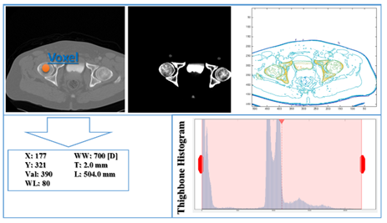
Figure 1: Identifying voxel value located in the femoral area of a DICOM and thigh bone histogram generation.

Discussion
The bone density extraction from patients’ C.T. scans helps us to develop a mechanical bone characterization “map” which can be used to define a “biomechanically faithful” endoprosthesis highly compatible with patients’ thighbone morphology. In DICOM files, a value is directly related to the linear alteration coefficient for the X-Ray and is usually calibrated to 0 for water and to -1000 for air, in this regard studies have shown that values around -120 corresponds to fat, +40 corresponds to muscle and +400 corresponds to bone tissue. This information will help us to develop a code which can automatically select voxels having approximate values equal to +400 to extract only the values that we are interested in, those describing femoral bone tissue.

References
- Collin, A. B. et al., “In Situ Studies of Wear Process,” ASME J. Tribology, 120, 3, 1995, 513-519.

